ELE8059 Assignment 2



Student ID : 40178580

Ben Russell

Date : 20/02/2023

# **Overview**

This report aims to estimate the inter-peak interval, and amplitudes of the primary and secondary peak in an ECG waveform. The report will follow 4 main stages of analysis, these are:

1) Time-Frequency analysis will be complete on the provided noise-corrupt ECG signal, and the frequencies at which any spurious components fall will be identified.

2) A suitable approach to eliminate the identified noise will be proposed. This will use digital filters and follow approaches currently used in relevant literature.

3) The digital filters will be designed on MATLAB, and applied in the time domain to the measurement signal, with the aim to produce a clean ECG signal with easily identifiable peaks/features.

4) The inter-peak interval will be estimated by visual inspection.

5) The height of both the primary-peak and secondary-peak will be estimated by visual inspection.

# Q1 - Time-Frequency Analysis

The first step to solve this problem is to identify the frequency bands that we need to filter from the ECG signal. We expect the ECG signal to be a periodic (Roughly) signal and so looking in the time-frequency domain, we should be able to easily the frequencies at which noise is being introduced to the signal. Provided this noise falls outside of the frequency range of the primary and secondary peaks, or follows a fixed, continuous frequency (Ie mains noise at 50Hz)

To begin, we can look at the signal purely in the time-domain. For this particular signal, this can allow us to appreciate why we can’t just rely on the time domain and need to further our analysis to the frequency domain:

Figure Noise Corrupt ECG signal in the time domain.

Figure 1 clearly shows how this signal would be very challenging to interpret, especially when most of the automated analysis around ECG’s is done in the time domain (R-Peak detection, HR, HRV ect)

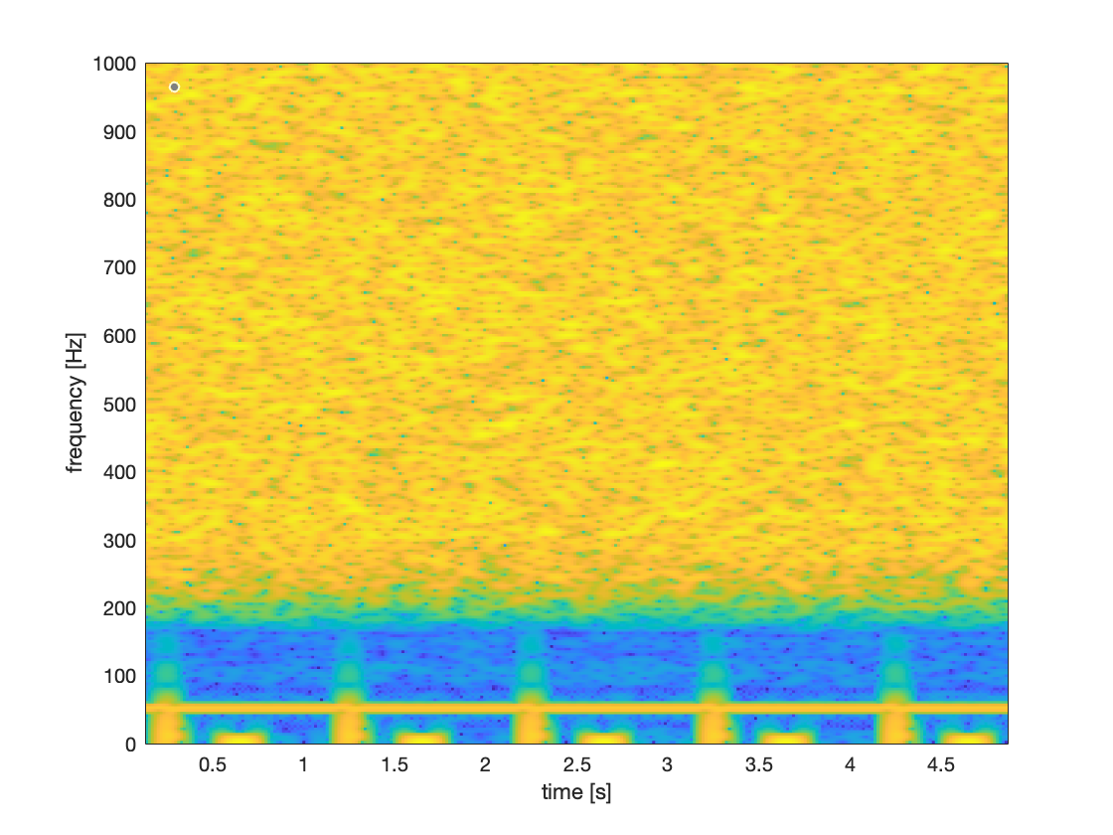We can plot a spectrogram of the above signal, to investigate how the frequency components change with respect to time. This has been done in MATLAB using the spectrogram.m function:

Figure Spectrogram of the ECG signal. Showing how the frequency components vary over time,

From figure 2, we can easily identify the spurious components that have been introduced into the signal. The periodic peaks we can see are the primary and secondary waves that we are looking to investigate, and so we need to maintain these as much as possible.

Now, we can see the signal is clearly corrupt with a high power of high frequency noise. This noise falls outside the frequency range of our primary and secondary waves and so should not present much of a challenge to remove, a low-pass filter with a cut-off ~190Hz should be satisfactory.

We can also see a continuous line around the 50Hz mark, this not a periodic signal and so is likely not part of our desired ECG signal. The fact that is fixed at 50Hz suggests that this is powerline interference noise, a very common type of noise caused by mains interference. This noise type overlaps with the frequency band of our desired ECG waveforms, and so may present a higher level of difficulty to remove. However there have been a plethora of algorithms that have been shown to remove mains noise without significantly effecting the original ECG signal.

# Q2 - Identify and motivate a suitable approach to remove the noise.

We have identified 2 primary noise components contained within this signal. As such, we can remove all the noise using 2 digital filters. We need to develop an algorithm that has the following to objectives:

1. Applies a suitable notch filter that does not add distortion to the original ECG waveform.
2. Applies a suitable low-pass filter that does not distort the original ECG.

Since 50Hz noise overlaps with the frequency range of our primary and secondary waves under investigation, this will likely prove to be tricky, however there have been methods to reduce this type of noise done in previous literature that will be used as part of our algorithm.

The High Frequency noise in our signal falls outside our primary and secondary wave frequency range so this should not be difficult to complete.]

The following flow chart outlines the premise of our proposed algorithm:

Filtered Signal

Low Pass Filter

Adaptive Notch Filter

Noisy ECG signal

The adaptive notch filter will be designed based on the method outlined in [1]. This approach should remove most of the 50Hz noise without interfering with the original ECG signal.

The lowpass.m built in MATLAB function will be employed to calculate the required filter coefficients and the filter.m function will be used to carry out the low-pass filtering.

# Q3 – Design of the Filters.